**ĐẠI HỌC THỦ DẦU MỘT**

**KHOA KỸ THUẬT – CÔNG NGHỆ**



**TIỂU LUẬN MÔN HỌC**

**ĐỒ ÁN CƠ SỞ NGHÀNH**

|  |  |  |
| --- | --- | --- |
| **Lecturer: Hồ Đắc Hưng** | | |
| **Team Name:** | **Nguyễn Minh Kha** | **1724801030063** |
|  | **Nguyễn Đạt Phi** | **1724801030093** |
|  | **Hoàng Tiến Phúc** | **1724801030098** |
| **Class: D17PM02** | | |

**BÌNH DƯƠNG – 12/2019**

**TABLE OF CONTENTS**

**CHAPTER  1: INTRODUCTION 1**

**1.1. Purpose 1**

**1.2. Scope 1**

**1.3. Overview 1**

**1.4. References Meterial 1**

**CHAPTER 2: SYSTEM OVERVIEW 2**

**CHAPTER 3: SYSTEM ARCHITECTURE 3**

**3.1. Architectural design 3**

**3.2. Decomposition description 4**

**3.3. Design rationable 5**

**CHAPTER 4: DATA DESIGN 6**

**4.1. Data description 6**

**4.2. Data dictionary 6**

**CHAPTER 5: COMPONENT DESIGN 7**

**5.1. Select Time Modul 7**

**5.2. Child Modul 7**

**5.3. Setting Modul 7**

**CHAPTER 6: HUMAN INTERFACE DESIGN 8**

**6.1. Overview of user interface 8**

**6.2. Screen images 8**

**CHAPTER 8: APPENDICES 13**

# **CHAPTER  1: INTRODUCTION**

## **1.1. Purpose**

* This software design document describes the architecture and system design of Application that reminds users to take medicine.

**1.2. Scope**

* Today's smartphone is not just a device that helps listen, call, surf, play games or listen to music, but actually it is becoming a "personal doctor" with very effective healthcare applications. Smartphone health care applications can save many lives. Technology and Health have been together for the past decade. From AI-controlled prosthetics to tattoos (carbon tubes implanted under the skin) that read the level of sugar in the body, scientists are constantly developing technologies to keep people healthy. better and happier.
* Many health-changing mobile phone applications have been developed over the years, from diabetes monitoring tools to AI-controlled diagnostic applications. Turning your phone into a medical device and a "personal doctor" is the way scientists are helping people reduce their growing medical expenses.
  + Patient of the hospital.

**1.3. Overview**

* + The application is developed on the Android studio platform.
  + Application intended to help users take medication on time.

**1.4. References Meterial**

[1] [https://www.manulife.com.vn](https://www.manulife.com.vn/)

[2] <https://bluecare.vn/>

[3] <https://www.youtube.com/playlist?list=PLzrVYRai0riSRJ3M3bifVWWRq5eJMu6tv>

[4]<http://giasutinhoc.vn/lap-trinh/lap-trinh-android-co-ban/luu-tru-du-lieu-trong-android-bai-5-2/>

CHAPTER 2: SYSTEM OVERVIEW

To ensure their health the patient needs to follow the doctor's appointment of the medication on time so the application This is born to remind the forgetful patients. The application includes the user operation interface and the setting interface with the following properties Add Notice, Route Name, Set your alam time, Add Child, Setting, Vibrate, Volumte, Record your own alarm, Record your own video alarm, Passenger Manager, Alarm Selection. On the operation interface for system users, it will allow users to set up a schedule to notify about their medication time, including the name of the recalled name and the time and schedule of notification after Settings will be saved on the system and reused when necessary.

# **CHAPTER 3: SYSTEM ARCHITECTURE**

## **3.1. Architectural design**

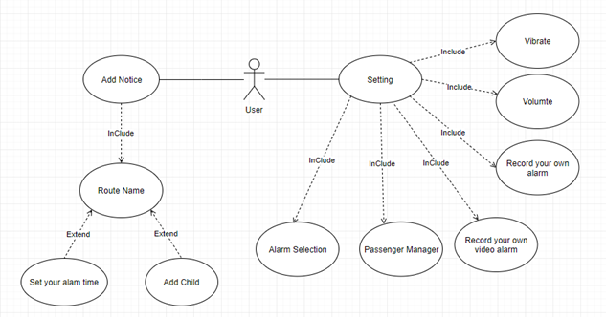

### **Figure 3.1. Use Case Diagram**

**3.2. Decomposition description**

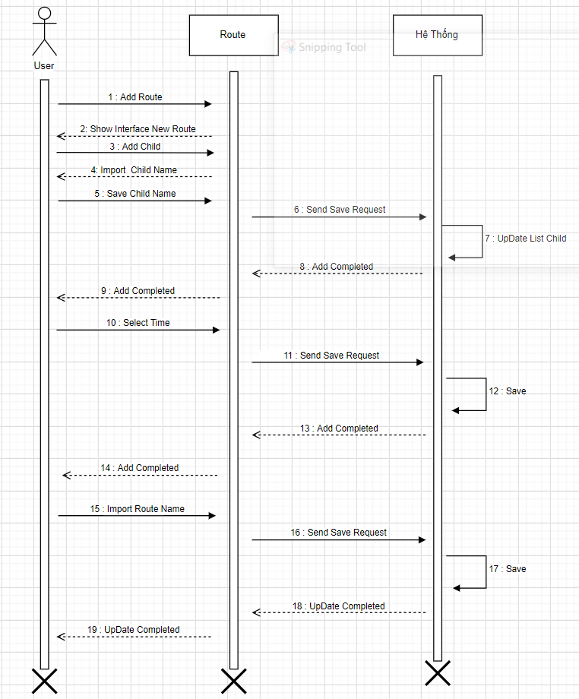

**Figure 3.2. Sequence diagram**

## **3.3. Design rationable**

* Your client is on the internet.
* Increase prestige and brand value.
* Most convenient for customers.
* To introduce products and services professionally.
* Customer service is better.
* Our benefits - Business 24 months days.
* Building – brand development.

CHAPTER 4: DATA DESIGN

## **4.1. Data description**

## **4.2. Data dictionary**

# **CHAPTER 5: COMPONENT DESIGN**

## **5.1. Select Time Modul**

In this module, users can set alarm time / day / hour / minute for personal use.

## **5.2. Child Modul**

This is a module that allows users to set reminders for their notifications.

## **5.3. Setting Modul**

This is a module that allows users to set a ringtone of notification video volume and vibration of application prompts

# **CHAPTER 6: HUMAN INTERFACE DESIGN**

## **6.1. Overview of user interface**

## **6.2. Screen images**

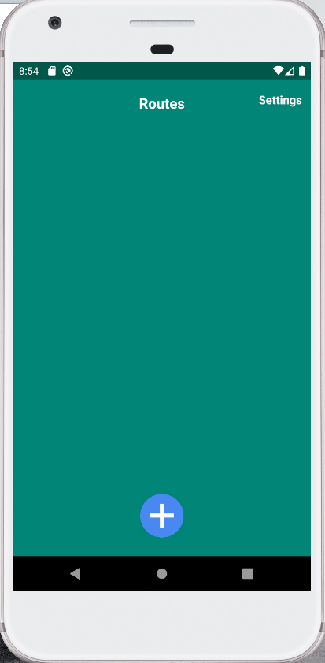

### **Figure 6.1.** **Main interface**

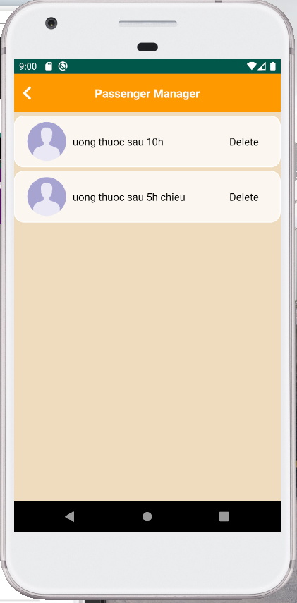

### **Figure 6.2. Passenger Manager Interface**

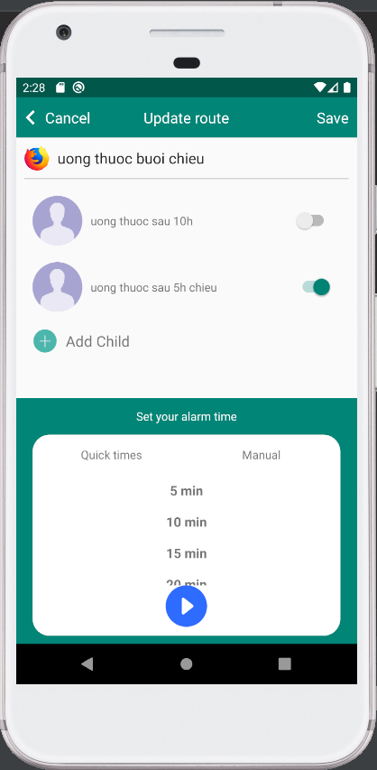

### **Figure 6.3. Update Route Interface**

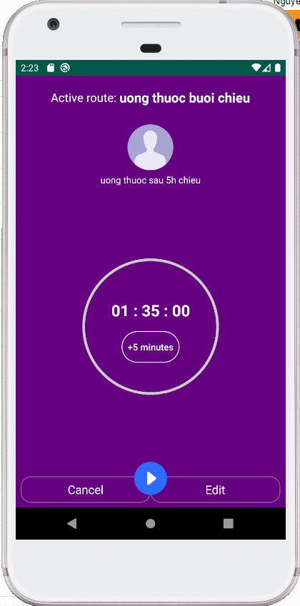

### **Figure 6.4. Notification Interface**

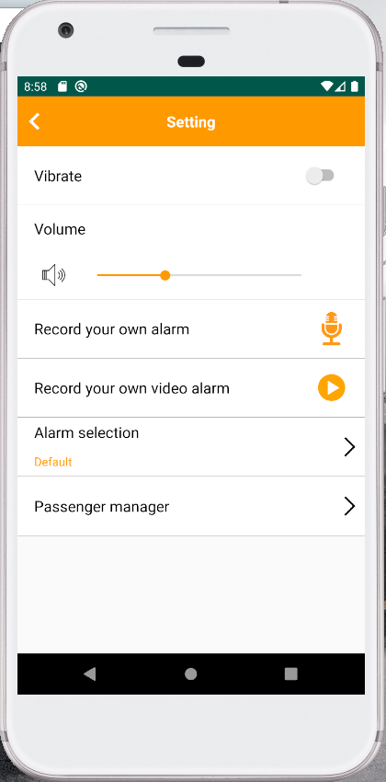

### **Figure 6.5. Setting Interface**

# **CHAPTER 8: APPENDICES**

**Figure 3.1. Use Case Diagram** 3

**Figure 3.2. Sequence diagram** 4

**Figure 6.1.** **Main interface** 8

**Figure 6.2. Passenger Manager Interface** 9

**Figure 6.3. Update Route Interface** 10

**Figure 6.4. Notification Interface** 11

**Figure 6.5. Setting Interface** 12